WEATHER PREDICTION

A Project Work
Submitted in Sixth Semester of Bachelor of Technology (BTech)

In
Computer Science & Engineering
(Session: 2022-23)



Submitted By

MUSKAN CHOUHAN

Enroll No: 0205CS201068

POOJA TEKAM

Enroll No: 0205CS201083

NIKITA PATEL

Enroll No: 0205CS201076

PRASHANT KUMAR

Enroll No: 0205CS201085

Under the Guidance of

Prof. SHWETA KRIPLANI

(Computer Sc. & Engg.)

DEPARTMENT OF COMPUTER SCIENCE & ENGINEERING
Shri Ram Institute of Technology, Jabalpur (M.P.)
Rajeev Gandhi Proudyogiki Vishwavidyalaya, Bhopal (M.P.)


CERTIFICATE

This is to certify that

MUSKAN CHOUHAN(Roll no-0205CS201068)

POOJA TEKAM (Roll no-0205CS201083)

NIKITA PATEL (Roll no-0205CS201076)

PRASHANT KUMAR (Roll no-0205CS201085)

students of 6th semester, Computer Sc. & Engg. S.R.I.T., Jabalpur have duly completed their Minor Project entitled “WEATHER PREDICTION ” for the Completion of 6th Semester examination under the requirement for the degree of Bachelor of Engineering as per R.G.P.V., Bhopal.

They have successfully implemented and tested this project, which meets all the requirements specified under my guidance.

Ms.SHWETA KRIPLANI  (Project Guide)  Computer Sc & Engg Deptt, SRIT |  | Mr. Brajesh Patel  (H.O.D.)  Computer Sc. & Engg Deptt., SRIT

PREFACE

Weather prediction today is largely based on expert systems. This is undoubtedly, a great solution. But the intricacies involved in computing the network required to infer all the cases is astronomically vast. Hence, a Machine learning based solution is capable of using a statistically tuned ML-agent that harnesses the capabilities of traversing every case there realistically could be to create a fine tuned system wherein projections would be rather accurate for a much less developmental cost and computational cost alike.
Chapter 1 provides the details regarding the introduction of the area of project, Software tools and technology used like React and Python.
Chapter 2 provides problem statement, Objective in term of functional and non functional requirements provided by the project
Chapter 3 includes various UML diagrams like use case diagrams, activity diagram, description about tables, ER diagrams and flow charts.
Chapter 4 includes testing, where the various modules testing is done to check whether the is according to the user, Unit testing and Integration testing is done on modules using different test cases.
Chapter 5 includes results with proper screen shots and description about the screenshots like its purpose, how this screen will appear etc.

ACKNOWLEDGEMENT

Engineers in all disciplines must acquire knowledge of project making. Student, in particular, will find ‘project making’ as an integral part of their studies that will infuse the spirit of doing practical work in them.
The satisfaction that accompanies the successful completion of any task would be incomplete without the mention of the people who made it possible whose constant guidance crowned our efforts with success.
We sincerely express our deep gratitude to the management of our college for giving us liberty to choose and to work on the most relevant project i.e. “Weather Prediction ”. We are thankful to Mr. Brajesh Patel (HOD CSE) for ensuring that we have a smooth environment at the college and lab. At the very outset we would like to offer our never ending thanks to our project supervisor Ms. Shweta Kriplani (Assistant Professor, CSE) who helped us with our project from the beginning till the end. His continuous surveillance over our work allowed us to work more efficiently.

MUSKAN CHOUHAN(0205CS201068)

POOJA TEKAM (0205CS201083)

NIKITA PATEL (0205CS201076)

PRASHANT KUMAR (0205CS201085)

DECLARATION OF STUDENT

We hereby declare that the work which is present in this project1 report entitled “Weather Prediction” in the partial fulfillment for the award of the degree of Bachelor of Technology .
Date:_____________

MUSKAN CHOUHAN(0205CS201068)

POOJA TEKAM (0205CS201083)

NIKITA PATEL (0205CS201076)

PRASHANT KUMAR (0205CS201085)

INDEX

Certificate ……………………………………………………………………………….... i
Preface………………………………………………………………………………….ii
Acknowledgement…………………………………….………………………………………..ii
Declaration of student…………………………………………………………………iii
INDEX…………………………………………………………………………………...…….iv
- Introduction
- Analysis
Objective of Project
Requirement Gathering
Hardware Requirement
Software Requirement
Feasibility Study
Software Development Life Cycle
Cost Estimation
- Design
Input Requirement
Design of Data Base (If Required)
ER Diagram (If Required)
Data Flow Diagram / Object diagram
Control Flow Diagram
System Flow Diagram

- Tools Used
- Coding
- Testing
- Output
- SWOT Analysis
- Conclusion
- Reference
- GitHub link

Chapter 1
Introduction

Weather forecasting is the task of predicting the state of the atmosphere at a future time and a specified location. Traditionally, this has been done through physical simulations in which the atmosphere is modeled as a fluid. The present state of the atmosphere is sampled, and the future state is computed by numerically solving the equations of fluid dynamics and thermodynamics. However, the system of ordinary differential equations that govern this physical model is unstable under perturbations, and uncertainties in the initial measurements of the atmospheric conditions and an incomplete understanding of complex atmospheric processes restrict the extent of accurate weather forecasting to a 10 day period, beyond which weather forecasts are significantly unreliable. Machine learning, on the contrary, is relatively robust to perturbations and doesn’t require a complete understanding of the physical processes that govern the atmosphere. Therefore, machine learning may represent a viable alternative to physical models in weather forecasting.
Machine learning is the ability of computer to learn without being explicitly programmed. It allows machines to find hidden patterns and insights. In supervised learning, we build a model based on labeled training data. The model is then used for mapping new examples. So, based on the observed weather patterns from the past, a model can be built and used to predict the weather.
This project work focuses on solving the weather prediction anomalies and in-efficiency based on linear regression algorithms and to formulate an efficient weather prediction model based on the linear regression algorithms .

Chapter 2
Analysis

2.1 Problem Statement

Weather prediction is a useful tool for informing populations of expected weather conditions. Weather prediction is a complex topic and poses significant variation in practice. We will attempt to understand and implement a weather prediction application using the linear regression.

2.2 Project Scope

- Weather forecasts are made by collecting as much data as possible about the current state of the atmosphere (particularly the temperature, humidity and wind) to determine how the atmosphere evolves in the future.
- However, the chaotic nature of the atmosphere makes the forecasts less accurate as the
range of the forecast increases.
- Traditional observations made at the surface of atmospheric pressure, temperature, wind speed, wind direction, humidity, precipitation are collected routinely from trained observers, automatic weather stations or buoys.During the data assimilation process, information gained from the observations is used In conjunction with a numerical model's most recent forecast for the time that observations were made to produce the meteorological analysis. The complicated equations which govern how the state of a fluid changes with time require supercomputers to solve them.
2.3 Design and Implementation Constraints
The product is developed using API server. The back-end database are CSV files on the basis of that, the prediction takes place. The product is a general-purpose application software in which any user can gather the predicted information. The linear regression is used that predicts the weather based on the previous analysis of a data.

2.4 User Documentation
The product is a general-purpose application software where any user can access the software to gather information about the weather based on a current or a previous data analysis. In this product the software makes a request to the server to access the current dataset through which the data is analyzed using various machine learning algorithms.

2.5 Assumptions and Dependencies
- The software product is dependent on a dataset that is been retrieved from the server using various commands.
- The product will work based on the algorithm that has been discussed above.

2.6 System Features

2.6.1 Actors
- User
- Historical data provider
- Administrator

2.7 Functional Requirements

2.7.1 Accessing a database
- The system should allow administrator to add historical weather data.
- The system should be able to recognize patterns in temperature, humidity, and wind with use of historical data.

2.7.2 Prediction algorithm
- System should periodically apply prediction algorithms or models on obtained data and store results to central database.
- System shall obtain and display confidence value for each prediction given to user.

2.7.3 Actions performed by system
• System shall allow users to check weather for future three days.

2.8 Non-Functional Requirements

2.8.1 User Non-Functional Requirements
- System shall allow for users to get prediction for weather within almost two mouse
clicks.
- System should ensure that features that do not require a user to be logged in.

2.8.2 System Non-Functional Requirements
- System should be able to run with core functionality from computer system.
- System should be able to show interactive animations to users regarding current and future climatic conditions.

2.8.3 Other Non-Functional Requirements
• System should textual prediction of climate conditions.

2.9 Other Requirements

2.9.1 Performance Requirements
The proposed software that we are going to develop will be used as the general-purpose application software. Therefore, it is expected that the database would perform functionally all the requirements that are specified by the user.

2.9.2 Safety Requirements
The database may get crashed at any certain time due to virus or operating system failure. Therefore, it is required to take the database backup

2.9.3 Security Requirements
We are going to develop a secured database for the user. Software Quality Attributes. The Quality of the database is maintained in such a way so that it can be very user friendly to all the users.

2.9.4 Hardware Requirements
The system requires a database in order to store persistent data.

2.9.5 Software Constraints
The development of the system will be constrained by the availability of required software such as web servers, dataset and development tools.

Chapter 3
Design

Among modeling languages Unified Modeling Language (UML) has become most popular. UML is commonly used in the design and implementation of any system and software architectures. To achieve functional and non functional requirements of the system, UML model helps. In order to initiate the programming phase of building software, UML tools help in the creation of source code from UML diagram. The main objective of this paper to model a Weather Prediction System (Linear Regression approach) using UML. Weather prediction is a challenging area. The future weather conditions are predicted by trained regression model. In this chapter, we proposed a UML model for Weather Prediction using linear regression which provide a technique for predicting weather. This proposed enhanced method for weather prediction has advantages over other techniques

3.1 Introduction
In software industries, Object Oriented Development process is widely used. Object-Oriented
Programming has heavily contributed toward a standardized method of modeling known as the Unified Modeling Language (UML). UML has become synonym for software modeling. UML is commonly used to model the software architecture as per the requirements and it includes a set of graphic notation techniques to create visual models of software-intensive systems. With the help of different UML diagrams for building the software, source code can be easily generated. The correctness of source code depends on the UML specification which needs to be standard, complete, precise, and unambiguous. A good UML specification leads to clearly defined semantics and an efficient code can be generated. The project is based upon the predicting Weather's condition.

3.1.1 Proposed approach
The proposed System using an enhanced approach is tested using the dataset of last 6 years from (2013-2019). The results are compared with previous methods results. The proposed enhanced method for weather prediction has advantages over the traditional techniques. This model produces the most accurate forecasts in comparison with previous techniques. This system can help the meteorologist to predict the future weather easily with accuracy.

3.1.2 Weather Prediction System Architecture
The system is developed in python along with javascript. Daily data sets of last 6 years (2013-
2019) has been fetched to train our model. The system takes input from the datasets and produces the result.
The system building process consists of following sequential steps:
- Fetching the dataset
- Cleaning the dataset
- Selection of the features of dataset
- Train Model
- Use the model to predict results.

3.2 Use-Case Diagram
An interaction between a user and a system is described by use case diagram. Use case diagrams describe what a system does from the standpoint of an external observer. The emphasis is on what a system does rather than how. Use case diagrams are closely connected to scenarios. A scenario is an example of what happens when someone interacts with the system. A use case diagram is a collection of actors, use cases, and their communications.
- Tools Used

1 . PYTHON
2. Pycharm

- Coding

from functools import reduce
import pandas as pd
import pprint

class Classifier():
data = None
class_attr = None
priori = {}
cp = {}
hypothesis = None

def __init__(self,filename=None, class_attr=None ):
self.data = pd.read_csv(filename, sep=',', header =(0))
self.class_attr = class_attr

'''
probability(class) = How many times it appears in cloumn
__________________________________________
count of all class attribute
'''
def calculate_priori(self):
class_values = list(set(self.data[self.class_attr]))
class_data = list(self.data[self.class_attr])
for i in class_values:
self.priori[i] = class_data.count(i)/float(len(class_data))
print ("Priori Values: ", self.priori)

'''
Here we calculate the individual probabilites
P(outcome|evidence) = P(Likelihood of Evidence) x Prior prob of outcome
___________________________________________
P(Evidence)
'''
def get_cp(self, attr, attr_type, class_value):
data_attr = list(self.data[attr])
class_data = list(self.data[self.class_attr])
total =1
for i in range(0, len(data_attr)):
if class_data[i] == class_value and data_attr[i] == attr_type:
total+=1
return total/float(class_data.count(class_value))

'''
Here we calculate Likelihood of Evidence and multiple all individual probabilities with priori
(Outcome|Multiple Evidence) = P(Evidence1|Outcome) x P(Evidence2|outcome) x ... x P(EvidenceN|outcome) x P(Outcome)
scaled by P(Multiple Evidence)
'''
def calculate_conditional_probabilities(self, hypothesis):
for i in self.priori:
self.cp[i] = {}
for j in hypothesis:
self.cp[i].update({ hypothesis[j]: self.get_cp(j, hypothesis[j], i)})
print ("\nCalculated Conditional Probabilities: \n")
pprint.pprint(self.cp)

def classify(self):
print ("Result: ")
for i in self.cp:
print (i, " ==> ", reduce(lambda x, y: x*y, self.cp[i].values())*self.priori[i])

''' Exit from the system it the input is "x" or "exit" '''
def exitSystem():
print("System Terminated!")
print("Thank you for using this system!")
exit()

if __name__ == "__main__":
c = Classifier(filename="dataset.csv", class_attr="Play")
print("Enter the correct values shown in the option! *Case Sensitive")
print("Enter 'x' or 'exit' to exit from the system")
outlook = input("Whats the weather outside? (Sunny, Rainy, Overcast):")
if outlook.lower() == 'x' or outlook.lower() == 'exit':
exitSystem()
temp = input("Whats the temperature today? (Hot, Mild, Cool):")
if temp.lower() == 'x' or temp.lower()== 'exit':
exitSystem()
humidity = input("Whats the humidity? (High, Normal):")
if humidity.lower() == 'x' or humidity.lower()== 'exit':
exitSystem()
windy = input("Is it windy tody? (t or f):")
if windy.lower() == 'x' or windy.lower()== 'exit':
exitSystem()

c.hypothesis = {"Outlook":outlook, "Temp":temp, "Humidity":humidity , "Windy":windy}
c.calculate_priori()
c.calculate_conditional_probabilities(c.hypothesis)
c.classify()

- Testing

Testing is the process of evaluating a system or its component with the intent to find whether it satisfies the specified requirement or not. Testing is executing a system in order to identify any gaps, errors, or missing requirements in contrary to the actual requirements. Systems should not be tested as a single, monolithic unit. The testing process should therefore proceed in the stages where testing is carried out incrementally in conjunction with system implementation. Errors in program components may come to light at a later stage of the testing process. The process is therefore an iterative one with information being fed back from later stage to earlier parts of the process. Following testings were done during the course of our project.

4.1 Unit Testing
Unit testing focuses verification efforts on the smaller unit of software design. Using the detailed design description as a guide, important control paths are tested to uncover errors within the boundary of the module. The relative complexity of the test and the error detected as a result is limited by the constraint scope established for unit testing. The unit test is always white box oriented, and the step can be conducted in parallel for multiple modules
- Tested individual python file by debugging and using print statement
- Individual Component rendering

4.2 Integration Testing
With unit testing the modules may function properly, but at times they may have inadvertent affect on another, sub function when combined, may not produce the desired functions; individually acceptable impression may be signed to unacceptable levels then global data structure may present problems. Integration testing is a systematic technique for constructing the program structure while at the same time conducting tests to uncover errors associated with interfacing. The objective is to take unit tested modules and build a program structure that has been dictated by the design.

- Output

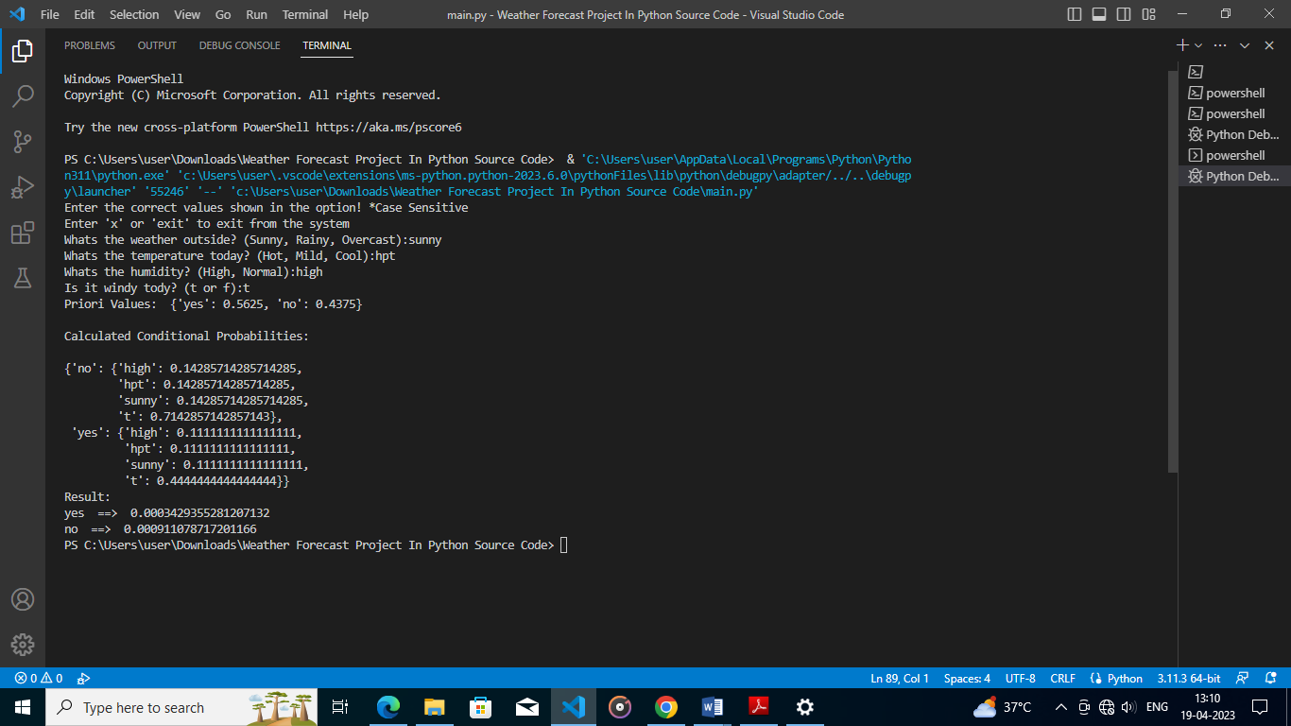

CONCLUSION
This research suggests and proposes an efficient and accurate weather prediction and forecasting model using linear regression concept. This concept is a part of machine learning. It is a very efficient weather prediction model and using the entities temperature, humidity and pressure, it can be used to make reliable weather predictions. This model also facilitates decision making in day to day life. It can yield even better results when applied to cleaner and larger datasets. Preprocessing of the datasets is effective in the prediction as unprocessed data can also affect the efficiency of the model.

REFERENCES
- https.wikipedia.com
- https.w3schools.com
- https.reactjs.org

